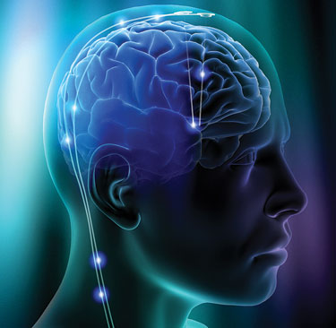

Brain Music Study

The laboratory of Professor Jessica Grahn in the Department of Psychology at the University of Western Ontario is seeking volunteers for a brain mapping study. The procedures involve functional magnetic resonance imaging (fMRI) and could also include some behavioural testing sessions. Participants will be compensated for their time. You will have to complete a screening questionnaire (10 minutes). Depending on how you answer this questionnaire, you may or may not be included in the fMRI study. Please contact Avital Sternin at *asternin@uwo.ca* for further information and / or to arrange for an appointment to go over the screening procedures.

Other Criteria:

* Right-handed with normal hearing
* Between 18 and 50 years of age
* No volunteers who are claustrophobic
* No pacemakers or other electronic implants in the body
* No metallic implants in the body
* No welders or soldiers
* No volunteers who are pregnant
* No cerebral aneurysm clips
* No history of neurological, psychiatric, heart, or lung disease
* No previous experience of epileptic seizures or familial history of epilepsy
* No volunteers who require prescribed psychotropic medication or currently take other medication that makes them drowsy
* No volunteers who get migraines or are susceptible to headaches

Brain Music Study

Grahn Lab

Avital Sternin

a*sternin@uwo.ca*

Brain Music Study

Grahn Lab

Avital Sternin

a*sternin@uwo.ca*

Brain Music Study

Grahn Lab

Avital Sternin

a*sternin@uwo.ca*

Brain Music Study

Grahn Lab

Avital Sternin

a*sternin@uwo.ca*

Brain Music Study

Grahn Lab

Avital Sternin

a*sternin@uwo.ca*

Brain Music Study

Grahn Lab

Avital Sternin

a*sternin@uwo.ca*

Brain Music Study

Grahn Lab

Avital Sternin

a*sternin@uwo.ca*

Brain Music Study

Grahn Lab

Avital Sternin

a*sternin@uwo.ca*

Brain Music Study

Grahn Lab

Avital Sternin

a*sternin@uwo.ca*